**Practical 01**

**AIM:-** **Design a HTML page describing your profile in one paragraph. Design in such a way has it has a heading, a horizontal rule, three links and your photo. Also, write three HTML documents for the links. Include facilities for forward, backward and HOME.**

**CODE: HOME PAGE**

**HTML:**

<!DOCTYPE html>

<html lang="en">

<head>

    <meta charset="UTF-8">

    <meta name="viewport" content="width=device-width, initial-scale=1.0">

    <title>PORTFOLIO</title>

</head>

<body>

    <header>

    <h1>Welcome to My Profile !</h1>

    <P>This is AMAN DIKTIYA, student of Information Technology. </P>

    <img src="Profilepicture.jpg" height=100px width="100px" alt="Profile Profilepicture">

    </header>

    <section>

        <h2>About Me </h2>

        <P> Hello I'm Aman Diktiya and here's a little info about Me.</P>

    </section>  <hr>

    <section><b>

        <a href="education.html">EDUCATION </a></b>

    </section>

    <hr>

    <section><b>

        <a href="projects.html">PROJETCS</a></b>

    </section><hr>

    <section>

        <b><a href="myskill.html"> SKILLS </a></b>

        </section><hr>

    <section>

        <h2>Contact Information</h2>

        <P> Let's Connect!</P>

        <pre><b>

        <a href="mailto:amandiktiya@gmail.com">Send me an Email</a>|

<a href="https://www.instagram.com/aman_diktiya_?igsh=MTI2NTVobXc4ZThyag==">Instagram</a>|

<a href="https://wa.me/qr/F4B4L6KCIFGXE1"> <b>WhatsApp</b> </a>

    </b>

</pre>

    </section>

</body>

</html>

**CSS:**

body {

font-family: 'Poppins', sans-serif;

background-color: #ffffff;

color: #070707;

line-height: 1.2;

}

h1, h2 {

font-weight: 700;

}

p {

font-weight: 400;

}

a {

color: #5092dd;

text-decoration: none;

}

a:hover {

color: #2113e4;

text-decoration: underline;

}

header {

background: linear-gradient(to right, #831bcd, #f9620b);

color: #0f0f0f;

padding: 5px 0;

text-align: center;

}

section {

padding: 0px;

text-align: center;

}

img {

width: 250px;

height: 250px;

border-color: #fcfcfc;

border-radius: 50%;

border-style: double;

border-width: 7px;

border-color: #080808;

box-shadow: 0 50px 200px rgba(236, 228, 228, 0.2);

object-fit: cover;

}

form

{

max-width: 500px;

margin: 20px auto;

padding: 20px;

background: #dde2e7;

box-shadow: 0 5px 15px rgba(14, 13, 13, 0.1);

}

form input[type="text"],

form input[type="email"],

form textarea {

width: calc(100% - 20px);

padding: 10px;

margin-bottom: 20px;

border: 1px solid #ccc;

border-radius: 5px;

}

form button {

background: #007bff;

color: #000000;

border: 0;

padding: 10px 20px;

border-radius: 5px;

cursor: pointer;

font-size: 18px;

}

form button:hover {

background: #0056b3;

}

footer {

background: linear-gradient(to right, #ce97f6, #db8e62);

color: #fff;

text-align: center;

padding: 20px 0;

position: relative;

bottom: 0;

width: 100%;

}

hr{

color: #0b0909;

size: 25px;

}

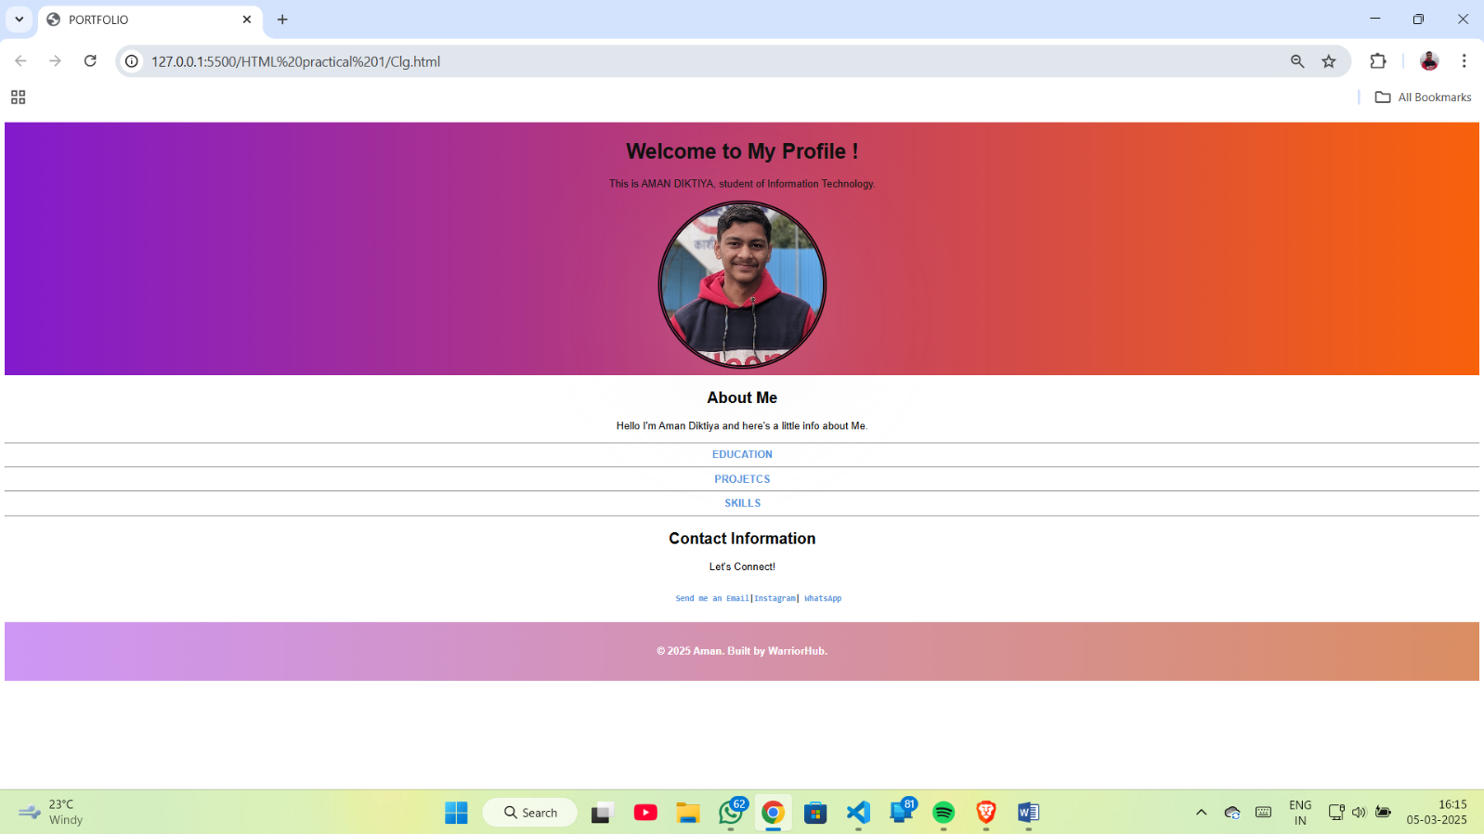

**CODE: EDUCATION PAGE:-**

**HTML:**

<!DOCTYPE html>

<html lang="en">

<head>

    <meta charset="UTF-8">

    <meta name="viewport" content="width=device-width, initial-scale=1.0">

    <title>EDUCATION</title>

    <link rel="stylesheet" href="education.css">

</head>

<body><h4>

    Hello Everyone My name is Aman Diktiya. I am student in Govt. Polytechnic Kashipur, 2nd year Information Technology.

    <br><br>

    My education Qualification mention below :- </h4>

    <br>    <hr>    <br>

    <*center*>

    <table>

        <tr >

          <TH>CLASS</TH>

          <th>BOARD/UNIVERSITY</th>

          <TH>YEAR</TH>

          <th>TOTAL MARKS </th>

          <th>OBTAINED MARKS</th>

          <th>PERCENTAGE</th>

        </tr>

        <tr>

          <td>HIGH SCHOOL</td>

          <TD>UTTARAKHAND BOARD</TD>

          <td>2021</td>

          <td>500</td>

          <td>398</td>

          <TD>79.6%</TD>

        </tr>

        <tr>

            <td>INTERMEDIATE</td>

            <TD>UTTARAKHAND BOARD</TD>

            <td>2023</td>

            <td>500</td>

            <td>343</td>

            <TD>69.6%</TD>

          </tr>

          <tr>

            <td>DIPLOMA </td>

            <TD>UBTER</TD>

            <TH>2026</TH>

            <td>1000</td>

            <td>856</td>

            <TD>85.6%</TD>

          </tr>

      </table>

    </*center*>

      <br><hr>

      <section><*center*>

      <a href="Clg.html"><b>Back to Page</b></a></*center*>

    </section>    <hr>

</body>

</html>

    SKILLS PAGE :-

<!DOCTYPE html>

<html lang="en">

<head>

    <meta charset="UTF-8">

    <meta name="viewport" content="width=device-width, initial-scale=1.0">

    <title>Document</title>

</head>

<body>

<h1><p>My Skills</p></h1>

        <centre>

        <table *align*="center">

            <tr>

                <td>

                    <ul style="text-align:left;">

                        <li>Web Development</li>

                        <li>Graphic Design</li>

                        <li>Photography</li>

                    </ul>

                </td>

            </tr>

        </table>

    </centre>

    <section><hr><b>

        <*center*>

        <a href="Clg.html">Back to Page</a>

    </*center*></b>

    <hr></section>

</body>

</html>

**CSS:**

table, th, td {

border-collapse: collapse;

}

th, td {

background-color: #96D4D4;

border-color: black;

border-style: groove;

text-align: center;

text-shadow: #fdfdfd;

}

section{

background: linear-gradient(to right, #caa4e4, #e38752);

text-align: center;

padding: 20px 0;

position: relative;

width: 100%;

font-size: large;

}

table{

text-align: justify;

text-indent: 1%;

}

th{

width:10%;

}

td{

width: 10%;

}

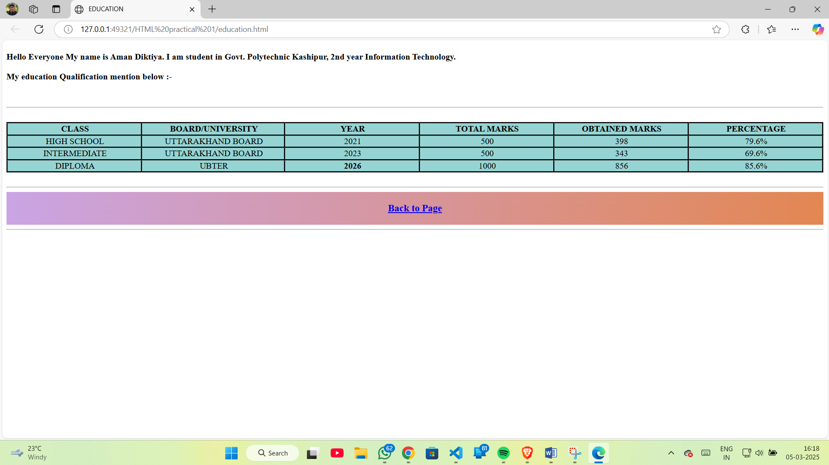

**CODE: PROJECTS PAGE:-**

**HTML:**

<!DOCTYPE html>

<html lang="en">

<head>

    <meta charset="UTF-8">

    <meta name="viewport" content="width=device-width, initial-scale=1.0">

    <title>Project</title>

</head>

<body>

    <H1>MY PROJETCS</H1>

    <section>

    <PRE><p><H4>

        <a href="project1.html">Project 1</a>

        <a href="project2.html">Project 2</a>

    </H4></p></PRE>

</section>

<section><hr><b>

            <*center*>

            <a href="main.html">Back to Page</a>

        </*center*></b>

        <hr></section>

</body>

</html>

**Project 1 :-**

<!DOCTYPE html>

<html lang="en">

<head>

<meta charset="UTF-8">

<meta name="viewport" content="width=device-width, initial-scale=1.0">

<title>Project 1</title>

<link rel="stylesheet" href="main.css">

<link rel="stylesheet" href="C:\Users\Aman Diktiya\Desktop\IWT Practical\HTML practical 1">

<style>

h2{

text-align: center;

}

</style>

</head>

<body>

<H2>Hello everyone</H2>

<br>

<h4>Creating a Portfolio web page . That's interface like This</h4>

<hr>

<b>

<header>

<h1>Welcome to My Profile !</h1>

<P>This is AMAN DIKTIYA, student of Information Technology. </P>

<img src="Profilepicture.jpg" height=100px width="100px" alt="Profile Profilepicture">

</header>

<section>

<h2>About Me </h2>

<P> Hello I'm Aman Diktiya and here's a little info about Me.</P>

</section>

<hr>

<section><b>

<a href="education.html">EDUCATION </a></b>

</section>

<hr>

<section><b>

<a href="projects.html">PROJETCS</a></b>

</section>

<hr>

<section>

<b><a href="myskill.html"> SKILLS </a></b>

</section>

<hr>

<section>

<h2>Contact Information</h2>

<P> Let's Connect!</P>

<pre>

<b>

<a href="mailto:amandiktiya@gmail.com">Send me an Email</a>|<a href="https://www.instagram.com/aman_diktiya_?igsh=MTI2NTVobXc4ZThyag==">Instagram</a>|<a href="https://wa.me/qr/F4B4L6KCIFGXE1"> <b>WhatsApp</b> </a>

</b>

</pre>

</section>

<footer>

<p><b> &copy; 2025 Aman. Built by WarriorHub.</b></p>

</footer>

<hr>

<center>

<a href="projects.html">Back to Page</a> |

<a href="project2.html">Project 2</a>

</center></b>

<hr>

</body>

</html>

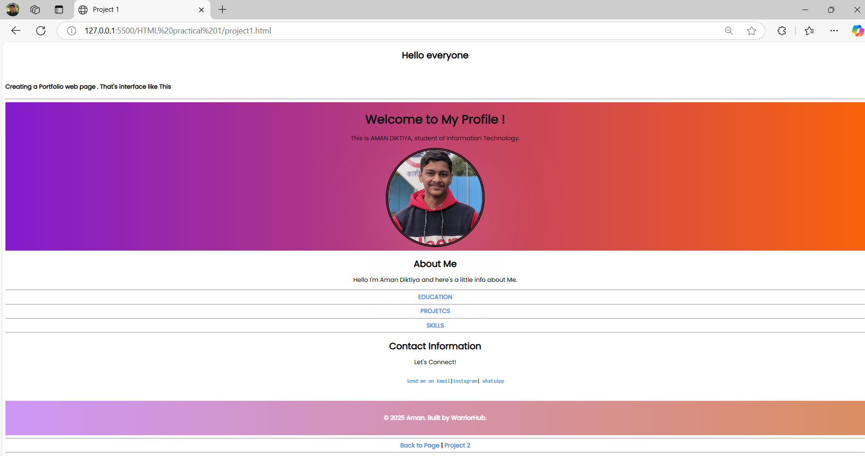

**Project 2:-**

<!DOCTYPE html>

<html lang="en">

<head>

<meta charset="UTF-8">

<meta name="viewport" content="width=device-width, initial-scale=1.0">

<title>Project 2</title>

</head>

<body>

<p>Technical Projects

PPT ( Markiting Presentation ,sound effects presentation) <br>

WE did land wire Projects in IOT <BR>

</p>

<CENTER>

<img src="p1.png" alt="" srcset="" height="500PX" width="1000PX" >

</CENTER>

<hr><b>

<center>

<a href="project1.html">Back to Page</a> |

<!-- <a href="project3.html">Projects 3</a> -->

<a href="Clg.html">Main Page</a>

</center></b>

<hr>

</body>

</html>

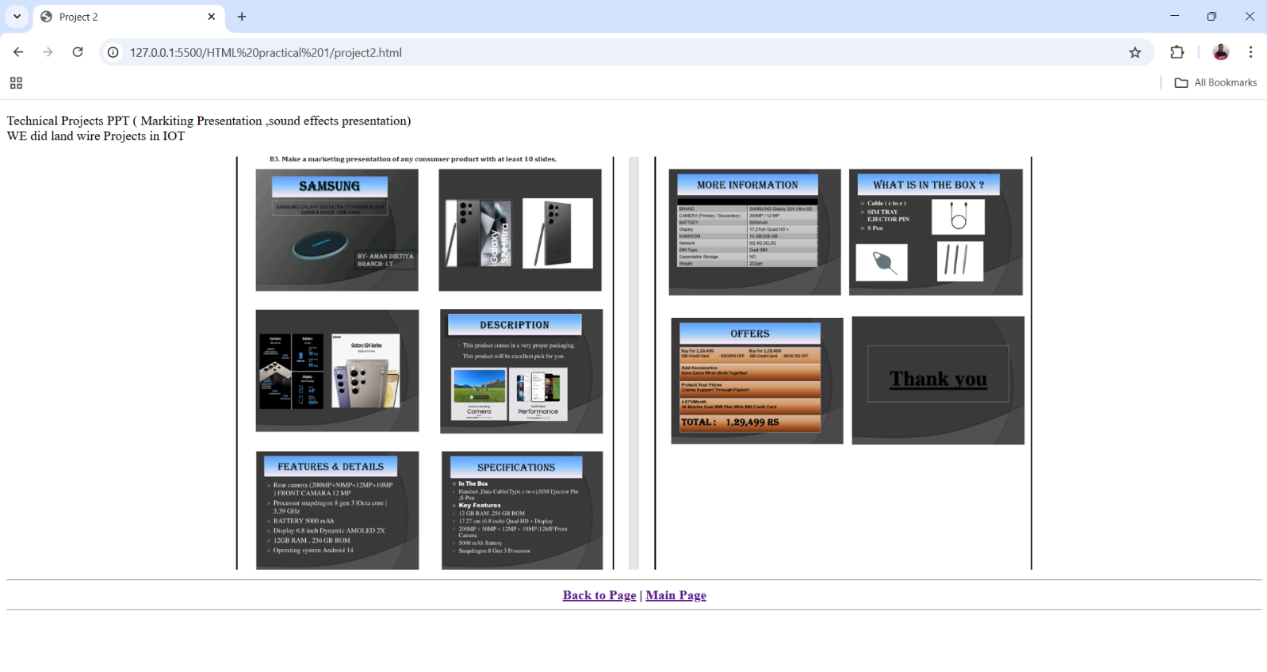

**PRACTICAL 02**

**AIM:- Design a HTML page about computer languages. List the language. Each Language’s name is a link. Prepare separate HTML documents for each language and call them in the appropriate link.**

**HTML:**

<!DOCTYPE html>

<html lang="en">

<head>

    <meta charset="UTF-8">

    <meta name="viewport" content="width=device-width, initial-scale=1.0">

    <link rel="stylesheet" href="language.css">

    <title>Computer Programming Language</title>

</head>

<body>

    <h1>Computer Programming Language  </h1>

    <hr>

  <p>Computer languages are used to write programs for computers and other devices. Some popular computer languages include C++, Python, HTML,CSS, JavaScript, C#, Ruby, Swift, and Go. </p>

  <h1>Popular computer languages :-</h1>

  <h2> <a href="c++.html">C++ </a></h2>

  <hr>

  <h2> <a href="python.html">PYTHON </a></h2>

  <hr>

  <h2> <a href="HTML.html">HTML</a></h2>

  <hr>

  <h2> <a href="JAVA.HTML">JAVASCRIPT</a></h2>

<hr>

</body>

</html>

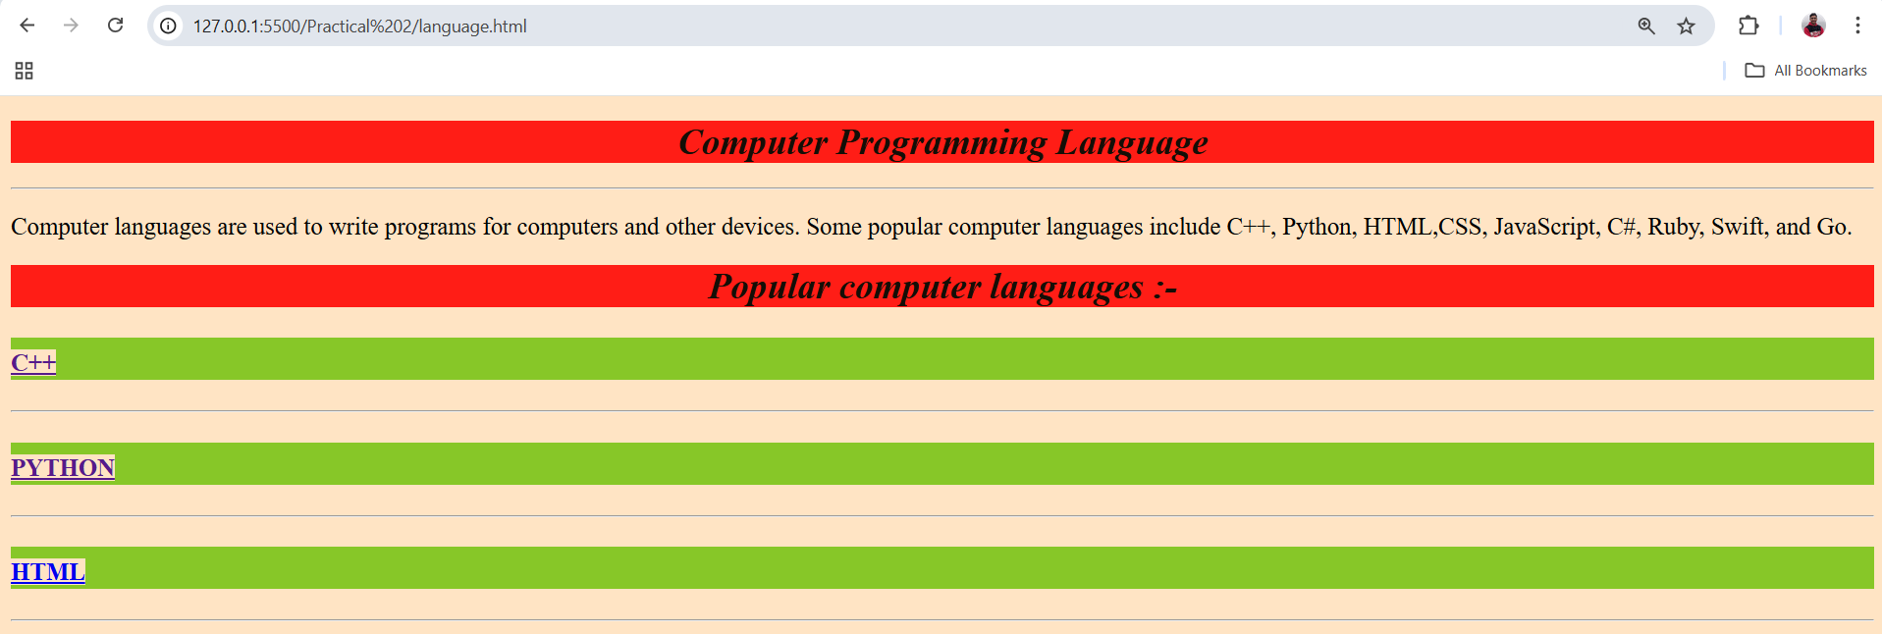

**C++ :**

<!DOCTYPE html>

<html lang="en">

<head>

    <meta charset="UTF-8">

    <meta name="viewport" content="width=device-width, initial-scale=1.0">

    <title> C++</title>

    <link rel="stylesheet" href="language.css">

</head>

<body>

    <p> C++ is a general-purpose programming language that was developed as an enhancement of the C language to include object-oriented paradigm. It is an imperative and a compiled language. C++ is a high-level, general-purpose programming language designed for system and application programming. It was developed by Bjarne Stroustrup at Bell Labs in 1983 as an extension of the C programming language.C++ is an object-oriented, multi-paradigm language that supports procedural, functional, and generic programming styles.One of the key features of C++ is its ability to support low-level, system-level programming, making it suitable for developing operating systems, device drivers, and other system software. At the same time, C++ also provides a rich set of libraries and features for high-level application programming, making it a popular choice for developing desktop applications, video games, and other complex applications. C++ has a large, active community of developers and users, and a wealth of resources and tools available for learning and using the language. Some of the key features of C++ include: Object-Oriented Programming: C++ supports object-oriented programming, allowing developers to create classes and objects and to define methods and properties for these objects.Templates: C++ templates allow developers to write generic code that can work with any data type, making it easier to write reusable and flexible code. <br>

    <b>More Information <a href="https://www.w3schools.com/cpp/">W3schools</a> | <a href="https://www.javatpoint.com/cpp-dictionaries">Javatpoint</a></b>

   </p>

   <hr>

   <section><center>

   <a href="language.html"><b>HOME</b></a></center>

 </section>

 <hr>

</body>

</html>

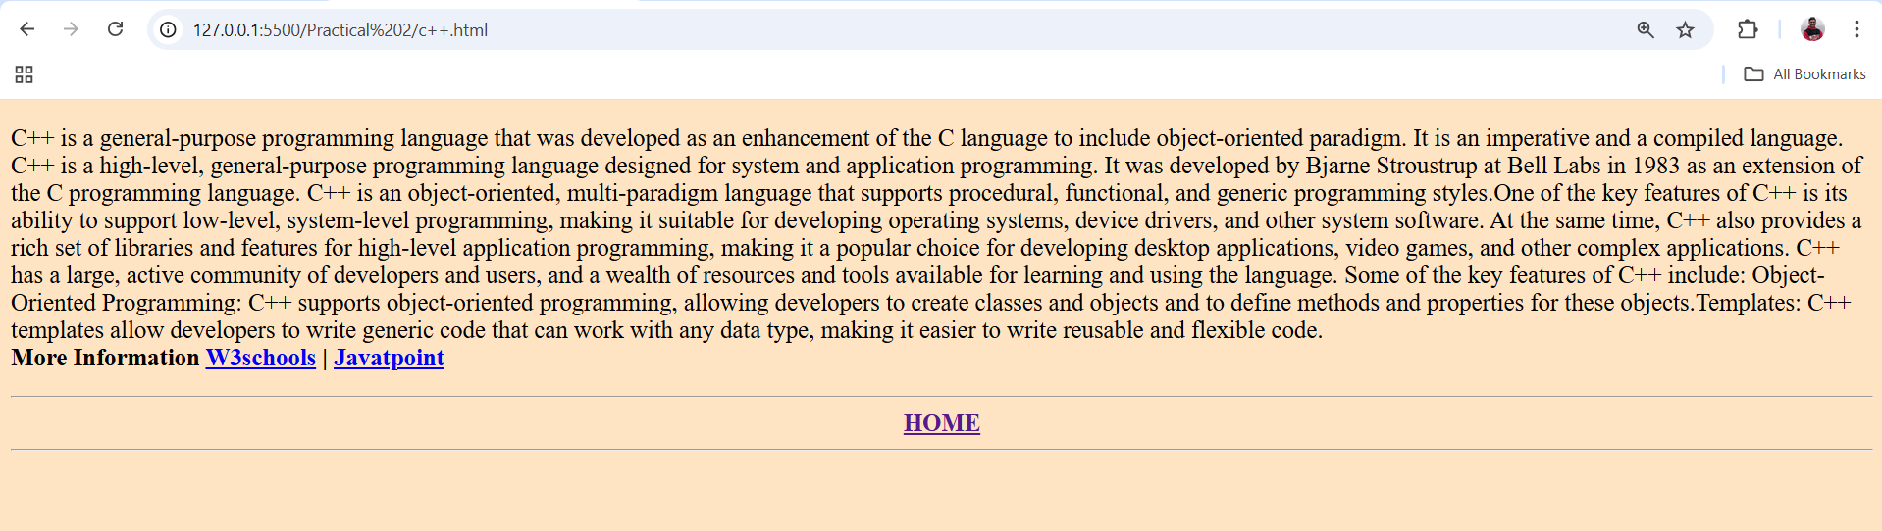

**PYTHON :**

<!DOCTYPE html>

<html lang="en">

<head>

    <meta charset="UTF-8">

    <meta name="viewport" content="width=device-width, initial-scale=1.0">

    <title>Introduction To Python</title>

    <link rel="stylesheet" href="language.css">

</head>

<body>

    <h2>Python</h2>

    <h3>

        What is Python?</h3>

        Python is a popular programming language. It was created by Guido van Rossum, and released in 1991. <br> <br>

        <b>It is used for:</b>

        <ul>

        <li>web development (server-side),</li>

        <li>software development,</li>

        <li>mathematics,</li>

        </ul>

        <h3>What can Python do?</h3>

        <ul>

            <li>Python can be used on a server to create web applications.</li>

            <li>Python can be used alongside software to create workflows.</li>

            <li>Python can connect to database systems. It can also read and modify files.</li>

        </ul>

        <h3>Why Python?</h3>

        <ul>

            <li>Python works on different platforms (Windows, Mac, Linux, Raspberry Pi, etc).</li>

            <li>Python has a simple syntax similar to the English language.</li>

            <li>Python has syntax that allows developers to write programs with fewer lines than some other programming languages.</li>

        </ul>

        <b>More Information <a href="https://www.w3schools.com/js/default.asp">W3schools</a> | <a href="https://www.tpointtech.com/python-tutorial">Javatpoint</a></b>

        <hr>

      <section><center>

      <a href="language.html"><b>HOME</b></a></center>

    </section>

    <hr>

</body>

</html>

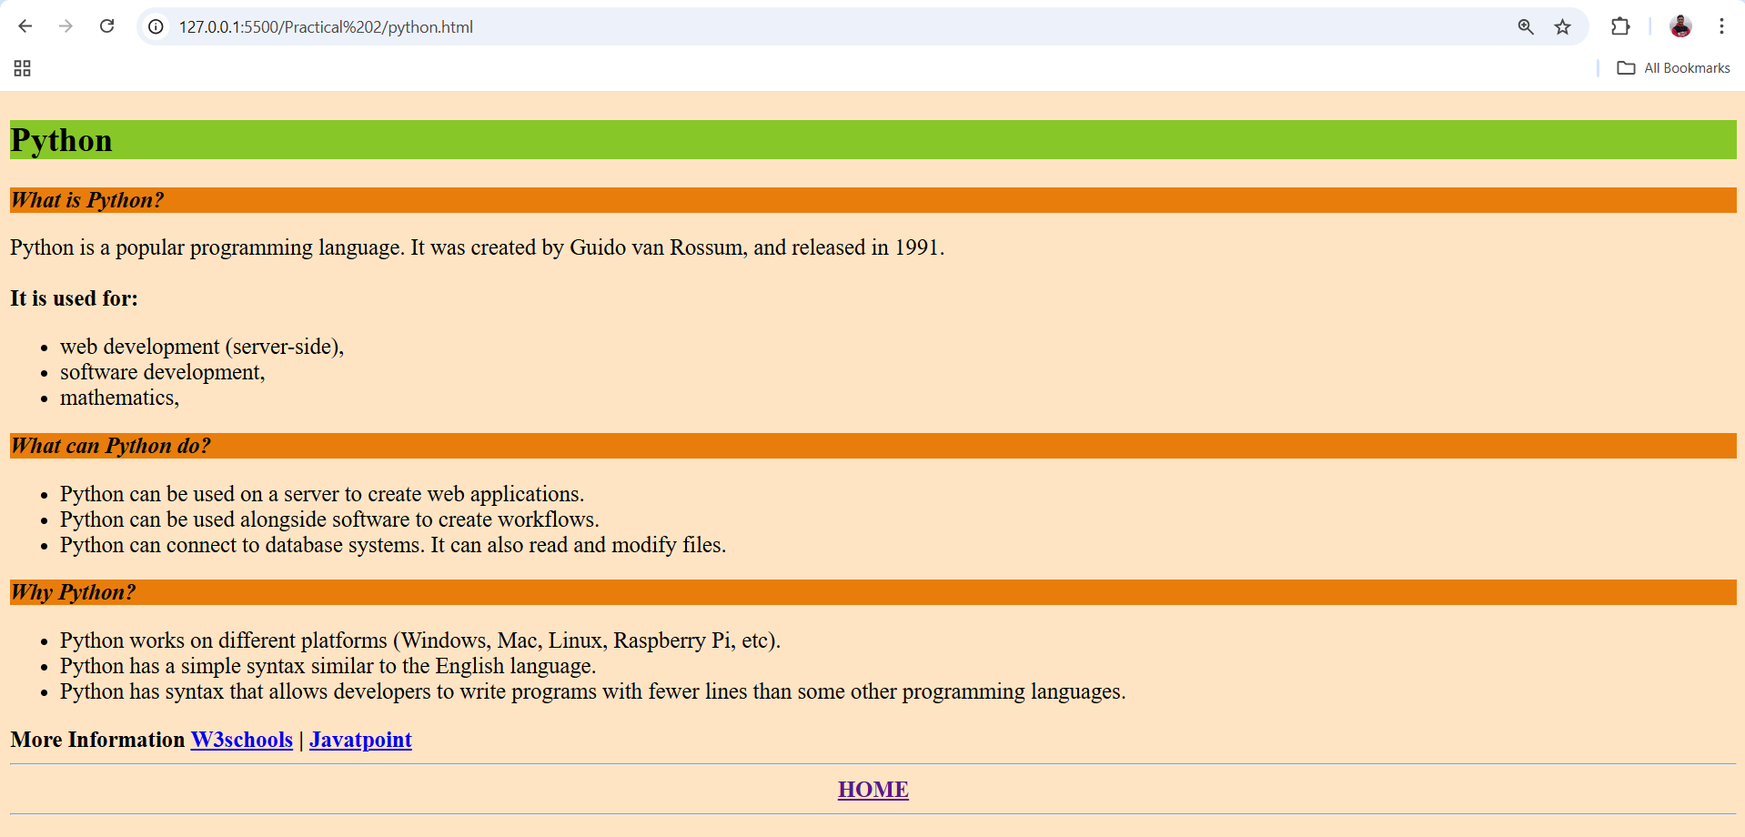

**HTML:**

<!DOCTYPE html>

<html lang="en">

<head>

    <meta charset="UTF-8">

    <meta name="viewport" content="width=device-width, initial-scale=1.0">

    <title> HTML</title>

    <link rel="stylesheet" href="language.css">

</head>

<body>

    <h2>HTML</h2>

    <h3>What is HTML?</h3>

    <ul>

        <li>HTML stands for Hyper Text Markup Language</li>

        <li>HTML is the standard markup language for creating Web pages</li>

        <li>HTML describes the structure of a Web page</li>

        <li>HTML consists of a series of elements</li>

        <li>HTML elements tell the browser how to display the content</li>

        <li>HTML elements label pieces of content such as "this is a heading", "this is a paragraph", "this is a link", etc.</li>

    </ul>

    <b>More Information <a href="https://www.w3schools.com/html/default.asp">W3schools</a> | <a href="https://www.tpointtech.com/html-tutorial">Javatpoint</a></b>

    <hr>

    <section><center>

    <a href="language.html"><b>HOME</b></a></center>

  </section>

  <hr>

</body>

</html>

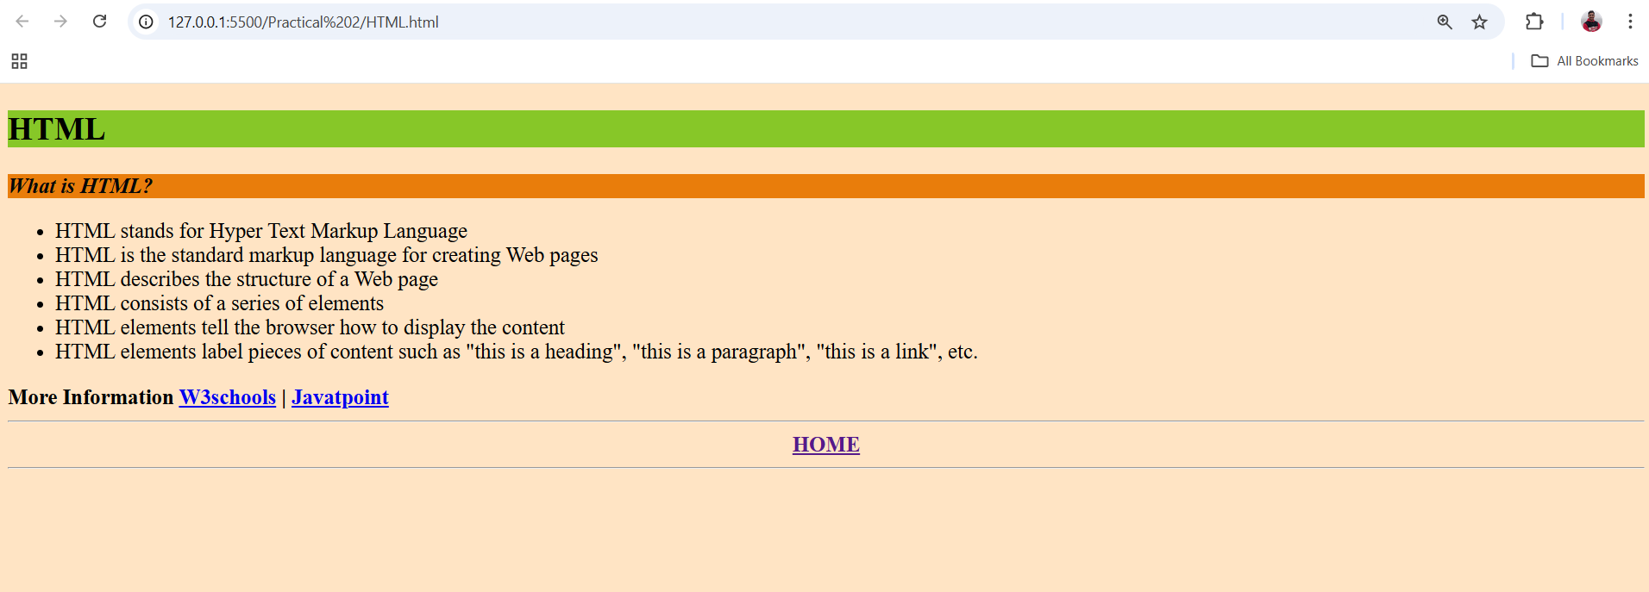

**PRACTICAL 03**

**AIM:-** **Design a single page website for your polytechnic containing a description of the courses offered. It should also contain some general information about the college such as its history, the campus, its unique features and so on. The site should be colored and each section should have a different color.**

<!DOCTYPE html>

<html lang="en">

<head>

    <meta charset="UTF-8">

    <meta name="viewport" content="width=device-width, initial-scale=1.0">

    <title>Document</title>

    <link rel="stylesheet" href="polyksp.css">

</head>

<body>

<body  >

<h1>GOVERNMENT POLYTECHNIC  KASHIPUR <br>

          Udham Singh Nagar

</h1>

<hr>

<div id="aman">

<b >The Institute at present is running following Courses :</b>

<ul>

    <li>Mechanical Engineering</li>

    <li>Civil Engineering</li>

    <li>Computer Science and Engineering</li>

    <li>Information TechnologyEngineering</li>

    <li>Agricultural Engineering</li>

    <li>Chemical Paint Technology</li>

    <li>Pharmacy</li>

</ul></div>

<hr>

<div id="am">

<h2>History</h2>

<p>Established in 1975, for imparting technical education and to generate suitable technical manpower.

 The institute is fully financed by Government of Uttarakhand.

 The peace full, pollution free soruding and excellent infrastructure facilities make Government Polytechnic Kashipur

 an ideal setting for academic pursuits.</p></div>

<hr>

<div id="a">

    <h2>Campus</h2>

<p>Our polytechnic is a private college that offers a wide range of courses to students.

 Located in a bustling city, our college is housed in a modern and well-designed building.

The architecture is sleek and contemporary, providing a conducive environment for learning and growth.

As you step onto our college grounds, you'll be greeted by lush greenery and well-maintained gardens.

The campus is spacious, allowing students to engage in various activities and relax during breaks.

We have dedicated areas for sports and recreation, ensuring a well-rounded experience for our students.

Our college offers a diverse range of courses, catering to different interests and career paths.

From engineering and technology to business and design, students have plenty of options to choose from.

Our faculty members are highly qualified and experienced, providing quality education and guidance to our students.</p></div>

<hr>

<div id="b">

    <h2>Principal's Desk</h2>

<*center*><img src="download.jpg"></*center*>

<br>

<p>“Technical Education is an ornament in prosperity and a refuge in adversity”<br>

We are constantly reviewing our set up to update and improve while making sure<br>

 that students gain thinking skills, analytical frameworks, interpersonal and communication skills which will be advantageous to them in the future. <br>

We also ensure to provide students with a supportive and welcoming environment in which they will be encouraged to develop themselves personally and professionally.<br>

 We prepare students for a bright and positive future in the world of work or of further study.<br></div>

<hr>

<div id="c">

Mr. Birendra Pal Singh<br>

Principal<br>

Govt. Polytechnic, Kashipur<br></div>

<hr>

</body>

</html>.

</body>

</html>

**CSS:**

h1{

text-align: center;

color: rgb(7, 136, 136);

background-color: bisque;

}

h2{

text-align: center;

}

img{

border-radius: 50%;

border-color: rgb(121, 113, 113);

border-style: double;

border-width: 0.19cm;

}

hr{

border-width: 0.03cm;

border-color: black;

}

#aman{

background-color: rgb(203, 190, 174);

}

#am{

background-color: rgb(158, 184, 206);

}

#a{

background-color: rgb(129, 185, 235);

}

#b{

background-color: rgb(172, 202, 229);

}

#c{

background-color: rgb(203, 222, 94);

}

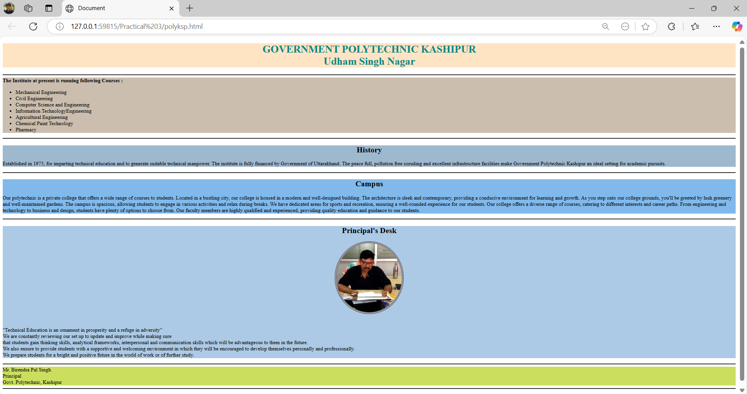

**PRACTICAL 04**

**AIM:- Develop a web page using CSS to create a time table for the class using different border style.**

**CODE:**

<!DOCTYPE html>

<html lang="en">

<head>

    <meta charset="UTF-8">

    <meta name="viewport" content="width=device-width, initial-scale=1.0">

    <title>Time Table</title>

    <link rel="stylesheet" href="TABLE.CSS">

</head>

<body>

    <h1>GOVERNMENT POLYTECHHNIC KASHIPUR</h1>

    <h3><P>TIME TABLE FOR <BR>

        IT 2<sUP>ND</sUP> YEAR</P></h3>

    <table>

        <tr>

          <h4>

            <th>DAY/TIME</th>

            <th>1<BR><br>10:00AM-11:50AM</th>

            <th>2<BR><br>10:50AM-11:40AM</th>

            <th>3<BR><br>11:40AM-12:30PM</th>

            <th>4<BR><br>12:30PM-1:20PM</th>

            <th>1:20PM-1:40PM</th>

            <th>5<BR><br>1:40PM-2:30PM</th>

            <th>6<BR><br>2:30PM-3:20PM</th>

            <th>7<BR><br>3:20PM-4:10PM</th>

            <th>8<BR><br>4:10PM-5:00PM</th>

          </h4>

        </tr>

     <tr>

        <td>MONDAY</td>

        <TD>RDBMS</TD>

        <td>RDBMS</td>

        <td>DSUC</td>

        <td>DSUC</td>

        <td rowspan="6">Lunch Time</td>

        <TD>IWT <br>Lab</TD>

        <TD>IWT <br>Lab</TD>

        <TD>RDBMS <br>Lab</TD>

        <TD>RDBMS <br>Lab</TD>

      </tr>

      <tr>

          <td>TUESDAY</td>

          <td>RDBMS</td>

          <td>RDBMS</td>

          <td>DSUC</td>

          <td>DSUC</td>

          <td>IWT <br>Lab</td>

          <td>IWT <br>Lab</td>

          <td>RDBMS <br>Lab</td>

          <TD>RDBMS <br>Lab</TD>

      </tr>

      <tr>

          <td>WEDNESDAY</td>

          <td>CSOA</td>

          <td>CSOA</td>

          <td>OOC <br>Lab</td>

          <td>OOC <br>Lab</td>

          <td>CNS <br>Lab</td>

          <td>CSN <br>LAB</td>

          <TD>G P</TD>

          <TD>G P</TD>

      </tr>

      <TR>

          <td>THRUSDAY</td>

          <td>CSOA</td>

          <td>CSOA</td>

          <td>OOC <br>Lab</td>

          <td>OOC <br>Lab</td>

          <td>CNS</td>

          <td>CNS</td>

          <TD>G P</TD>

          <TD>G P</TD>

      </TR>

      <TR>

          <td>FRIDAY</td>

          <td>OOC</td>

          <td>OOC</td>

          <td>IWT</td>

          <td>IWT</td>

          <td>DSUC <br>Lab</td>

          <td>DSUC <br>Lab</td>

          <TD>DSUC <br>Lab</TD>

          <td>DSUC <br>Lab</td>

         </TR>

        <TR>

          <td>SATURDAY</td>

          <td>OOC</td>

          <td>OOC</td><br>

          <td>IWT</td>

          <td>IWT</td>

            <td>OOC <br>Lab</td>

          <td>OOC <br>Lab</td>

          <td>OOC <br>Lab</td>

          <td>OOC <br>Lab</td>

        </TR>

</table>

  <pre>

</pre>

  <div>

    <table>

      <TR>

        <TH>SUBJECTS</TH>

        <TH>TEACHER</TH>

      </TR>

      <TR>

        <TD>DATA STRUCTURE USING C <b>(DSUC)</b></TD>

        <TD><*big*><b>Mrs.NEHA BORA</b></*big*></TD>

      </TR>

      <TR>

        <TD>OBJECTS ORIENTED CONCEPTS <b>(OOC)</b></TD>

        <TD><*big*><b>Mr.ASHOK KUMAR</b></*big*></TD>

      </TR>

      <TR>

        <TD> INTERNET AND WEB TECHNOLOGY <b>(IWT)</b></TD>

        <TD><*big*><b>Mrs. NEHA BORA</b></*big*></TD>

      </TR>

      <TR>

        <TD>RELATIONAL DATA BASE MANAGEMENT SYSTEM <b>(RDBMS)</b></TD>

        <TD><*big*><b>Mr. ASHOK KUMAR</b></*big*></TD>

      </TR>

      <TR>

        <TD>COMPUTER SYSTEM ORGANIZATION AND ARCHITECTURE <b>(CSOA)</b></TD>

        <TD><*big*><b>Mr. JAGDISH CHANDRA PANDAY</b></*big*></TD>

      </TR>

      <TR>

        <TD>COMPUTER NETWORK AND SECURITY <b>(CNS)</b></TD>

        <TD><*big*><b>Mrs. NEHA BORA</b></*big*></TD>

      </TR>

    </table>

  </div>

</body>

</html>

**CSS:**

body{

  border: solid;

border-color: rgb(4, 4, 4);

background-color: bisque;

}

tr,td{

  border: solid;

  border-color: rgb(9, 8, 8);

  background-color: rgb(168, 234, 234);

  width: 10%;

  height: 50%;

  font-style:oblique;

}

th{

  background-color: rgb(237, 137, 7);

  border: solid;

  width: 10%;

  height: 20%;

  font-style:normal;

  gap: 0.2cm;

}

table{

  text-align: center;

  width: 100%;

  height: 100%;

}

h1{

  text-align: center;

}

div{tr{

  height: 1.16cm;

  font-style:normal;

  b{

    color:rgb(236, 40, 14) ;

  }

}

}

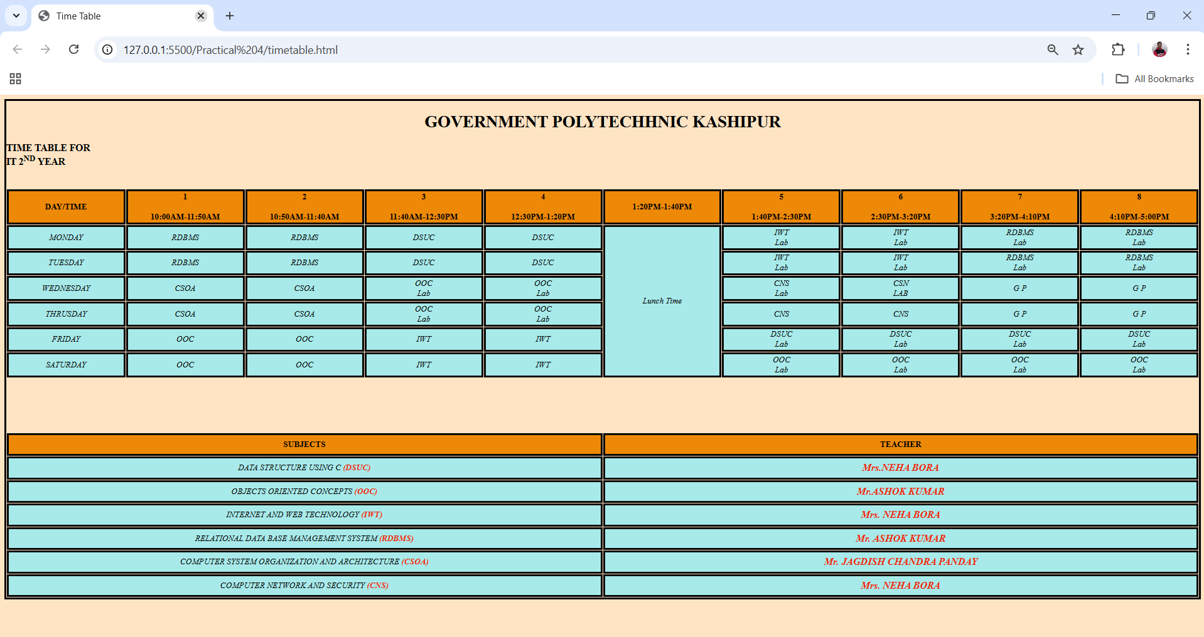**PRACTICAL 05**

**AIM:-** **a) Write a Java script code that converts the entered text to uppercase.**

**HTML CODE:-**

<html lang="en">

<head>

    <meta charset="UTF-8">

    <meta name="viewport" content="width=device-width, initial-scale=1.0">

    <title>Text to Uppercase</title>

    <link rel="stylesheet" href="part1.css">

    <script src="part1.js"></script>

    </head>

<body>

    <h2>Convert Text to Uppercase</h2>

    <input type="text" id="textInput" placeholder="Enter text">

    <button onclick="convertToUppercase()">Convert</button>

    <p>Uppercase Text: <span id="outputText"></span></p>

</body>

</html>

**CSS:-**

body {

    font-family: Arial, sans-serif;

    text-align: center;

    margin: 50px;

    background-color: #f4f4f4;

}

h2 {

    color: #333;

}

input {

    padding: 10px;

    width: 250px;

    font-size: 16px;

    border: 1px solid #ccc;

    border-radius: 5px;

}

button {

    padding: 10px 15px;

    margin-left: 10px;

    font-size: 16px;

    border: none;

    background-color: #007bff;

    color: white;

    border-radius: 5px;

    cursor: pointer;

}

button:hover {

    background-color: #0056b3;

}

p {

    margin-top: 20px;

    font-size: 18px;

    font-weight: bold;

}

#outputText {

    color: #d9534f;

}

**Java scripts:-**

function convertToUppercase() {

    let inputText = document.getElementById("textInput").value;

    let upperText = inputText.toUpperCase();

    document.getElementById("outputText").innerText = upperText;

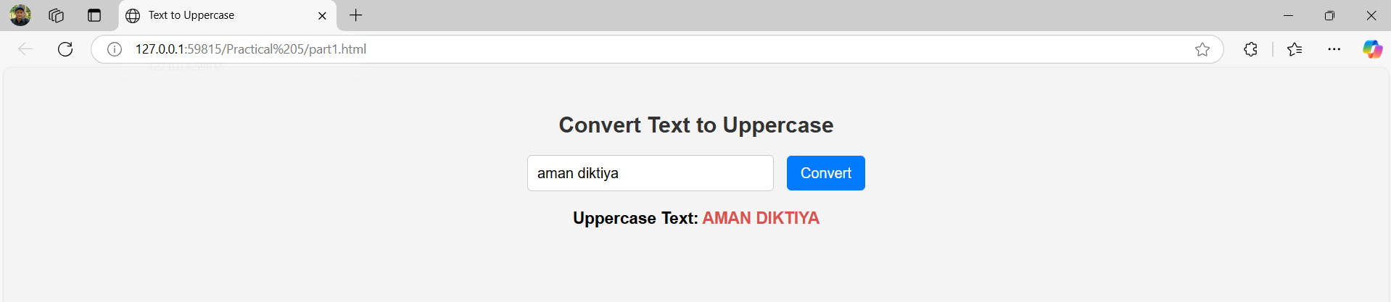}

**b) Write a Java script code to validate the username and password The username and password are stored invariables.**

**HTML CODE:-**

<!DOCTYPE html>

<html lang="en">

<head>

    <meta charset="UTF-8">

    <meta name="viewport" content="width=device-width, initial-scale=1.0">

    <title>Login Form Validation</title>

    <link rel="stylesheet" href="part2.css">

    <script src="part2.js"></script

</head>

<body>

    <div class="login-container">

        <h2>Login</h2>

        <form id="loginForm">

            <label for="username">Username:</label>

            <input type="text" id="username" placeholder="Enter username" required><br>

            <label for="password">Password:</label>

            <input type="password" id="password" placeholder="Enter password" required><br>

            <button type="button" onclick="validateLogin()">Login</button>

        </form>

        <p id="errorMessage"></p>

    </div>

</body>

</html>

**CSS:-**

body {

    font-family: Arial, sans-serif;

    background-color: #f4f4f4;

    display: flex;

    justify-content: center;

    align-items: center;

    height: 100vh;

    margin: 0;

}

.login-container {

    background-color: white;

    padding: 30px;

    border-radius: 10px;

    box-shadow: 0 0 15px rgba(0, 0, 0, 0.1);

    width: 300px;

    text-align: center;

}

h2 {

    color: #333;

}

input {

    width: 100%;

    padding: 10px;

    margin: 10px 0;

    border-radius: 5px;

    border: 1px solid #ccc;

}

button {

    width: 100%;

    padding: 10px;

    background-color: #4CAF50;

    color: white;

    border: none;

    border-radius: 5px;

    cursor: pointer;

}

button:hover {

    background-color: #45a049;

}

#errorMessage {

    color: red;

    font-size: 14px;

}

**JAVA SCRIPTS:-**

const correctUsername = "amandiktiya";

const correctPassword = "@2580";

function validateLogin() {

    const username = document.getElementById('username').value;

    const password = document.getElementById('password').value;

    const errorMessage = document.getElementById('errorMessage');

    errorMessage.textContent = '';

    if (username === correctUsername && password === correctPassword) {

               window.location.href = "https://www.instagram.com/"; // Replace with your desired URL

    } else {

        errorMessage.textContent = "Invalid username or password. Please try again.";

    }

}

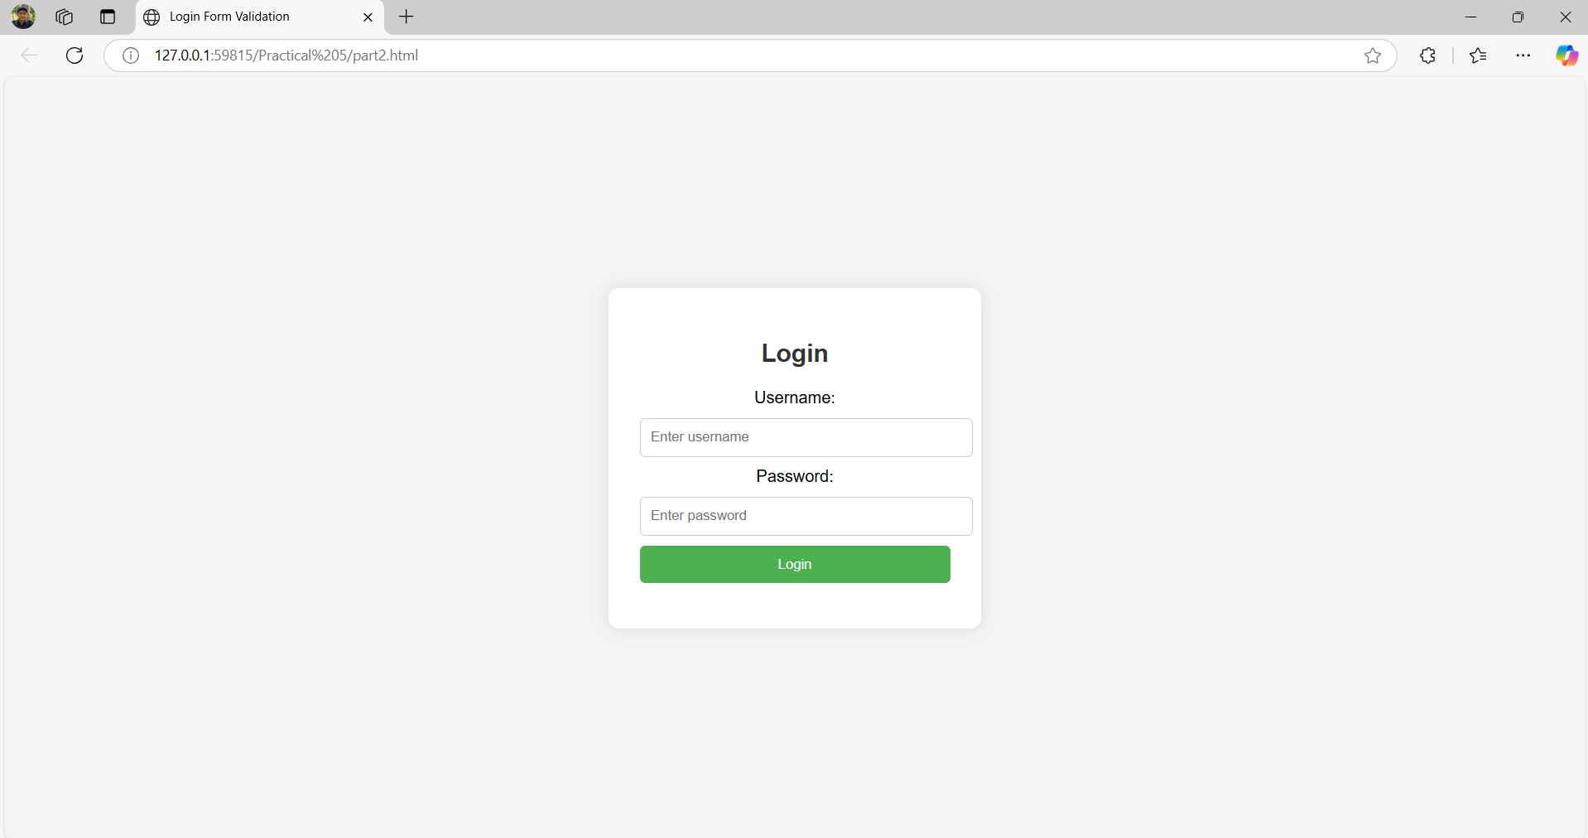

**PRACTICAL 06**

**AIM:-** **Write a Java Script code using frames and Events (When a cursor moves over an object it should display the specification of the object in another frame)**

HTML CODE:-

<!DOCTYPE html>

<html lang="en">

<head>

    <meta charset="UTF-8">

    <meta name="viewport" content="width=device-width, initial-scale=1.0">

    <title>Object Specification on Hover</title>

    <link rel="stylesheet" href="part1.css">

    <script src="part1.js"></script>

</head>

<body>

    <div class="container">

        <!-- Object frame that will display the clickable items -->

        <div class="object-frame">

            <h3>ProgrammingLanguages</h3>

            <div class="object" id="object1" onmouseover="showSpecification('HTML (HyperText Markup Language) is a markup language used to create and structure web pages. It is a standard language read and interpreted by web browsers. HTML is used to add structure and content to web pages, including 1. Headings and paragraphs: HTML defines headings and paragraphs using specific tags.2. Images and videos: HTML allows you to add images and videos to web pages.3. Links and navigation: HTML defines links and navigation using specific tags. 4. Forms and input fields: HTML enables you to create forms and input fields on web pages. 5. Tables and lists: HTML defines tables and lists using specific tags. ')">

            HTML

            </div>

            <div class="object" id="object2" onmouseover="showSpecification('CSS (Cascading Style Sheets) is a styling language used to control the layout and appearance of web pages written in HTML or XML. CSS is used to separate the presentation of a document from its structure, making it easier to maintain and update the layout and design of a website.')">

                CSS

            </div>

            <div class="object" id="object3" onmouseover="showSpecification(' JavaScript is a high-level, dynamic, and interpreted programming language that is primarily used for client-side scripting on the web. It allows developers to create interactive web pages, web applications, and mobile applications.')">

                JAVA SCRIPTS

            </div>

        </div>

        <!-- Specification frame that will display the details of the hovered object -->

        <div class="specification-frame" id="specificationFrame">

            <h3>Object Specification</h3>

            <p id="specificationText">Hover over an object to see its specification.</p>

        </div>

    </div>

</body>

</html>

**CSS:-**

body {

    font-family: Arial, sans-serif;

    display: flex;

    justify-content: center;

    align-items: center;

    height: 100vh;

    margin: 0;

    background-color: #f4f4f4;

}

.container {

    display: flex;

    width: 80%;

    justify-content: space-between;

}

.object-frame {

    width: 45%;

    padding: 20px;

    text-align: center;

    border: 2px solid #ccc;

    border-radius: 10px;

}

.specification-frame {

    width: 45%;

    padding: 20px;

    text-align: center;

    border: 2px solid #ccc;

    border-radius: 10px;

}

.object {

    margin-top: 20px;

    padding: 20px;

    background-color: #4CAF50;

    color: white;

    border-radius: 5px;

    cursor: pointer;

}

.object:hover {

    background-color: #45a049;

}

**JAVA SCRIPTS:-**

 function showSpecification(specification) {

    var specificationText = document.getElementById("specificationText");

    specificationText.textContent = specification;

